Eco News
Summer 2013

Silver Eco Schools Award!!

During the past year the Eco Group has been busy working towards the silver Eco Schools award and now we are proud to have been awarded it!

After the summer break we begin working for the Green Flag…...in what could be called our ‘bag a flag’ campaign!

More info about Eco Schools awards can be found at, http://www.keepscotlandbeautiful.org/sustainable-development-education/eco-schools

Litter – Many thanks to Costcutters and The Garret!

We are very grateful to Derek Ritchie and Linda Nicoll of
Costcutters and The Garret for their generous donations allowing us to buy litter grabbing equipment! This means we can ‘litter pick’ more often around school grounds and in the community. Two groups of pupils have already been out picking up litter as part of a maths survey.
Tackling the problem of litter will be a major focus for us in the next school session.

Fair Trade Tuck

Since ‘Fair Trade Week’, last March, a fair trade tuck shop stocked with ‘Traidcraft’ snacks has been open two break times each week in the newly refurbished social area. This is led by two third year girls who have volunteered to organise and serve each week and are counting this towards their Duke of Edinburgh award.
They have done a brilliant job this term – thank you girls!

http://www.fairtrade.org.uk/ 

Recycling opportunities at the academy

- Jewellery, old and foreign coins and mobile phones – please hand in to the office
- Clothing and shoes – salvation army recycling bin at far end of the car park - please put items in plastic bags and fasten shoes together in pairs
- Batteries, toner cartridges - hand to Mr McLennan (technician)
- Printer ink cartridges - hand to Miss Coleman (PE Dept.)

We recycle glass, plastic bottles, cans, paper and card and also
compost uncooked food waste from the Home Economics department and garden waste from our courtyard garden.

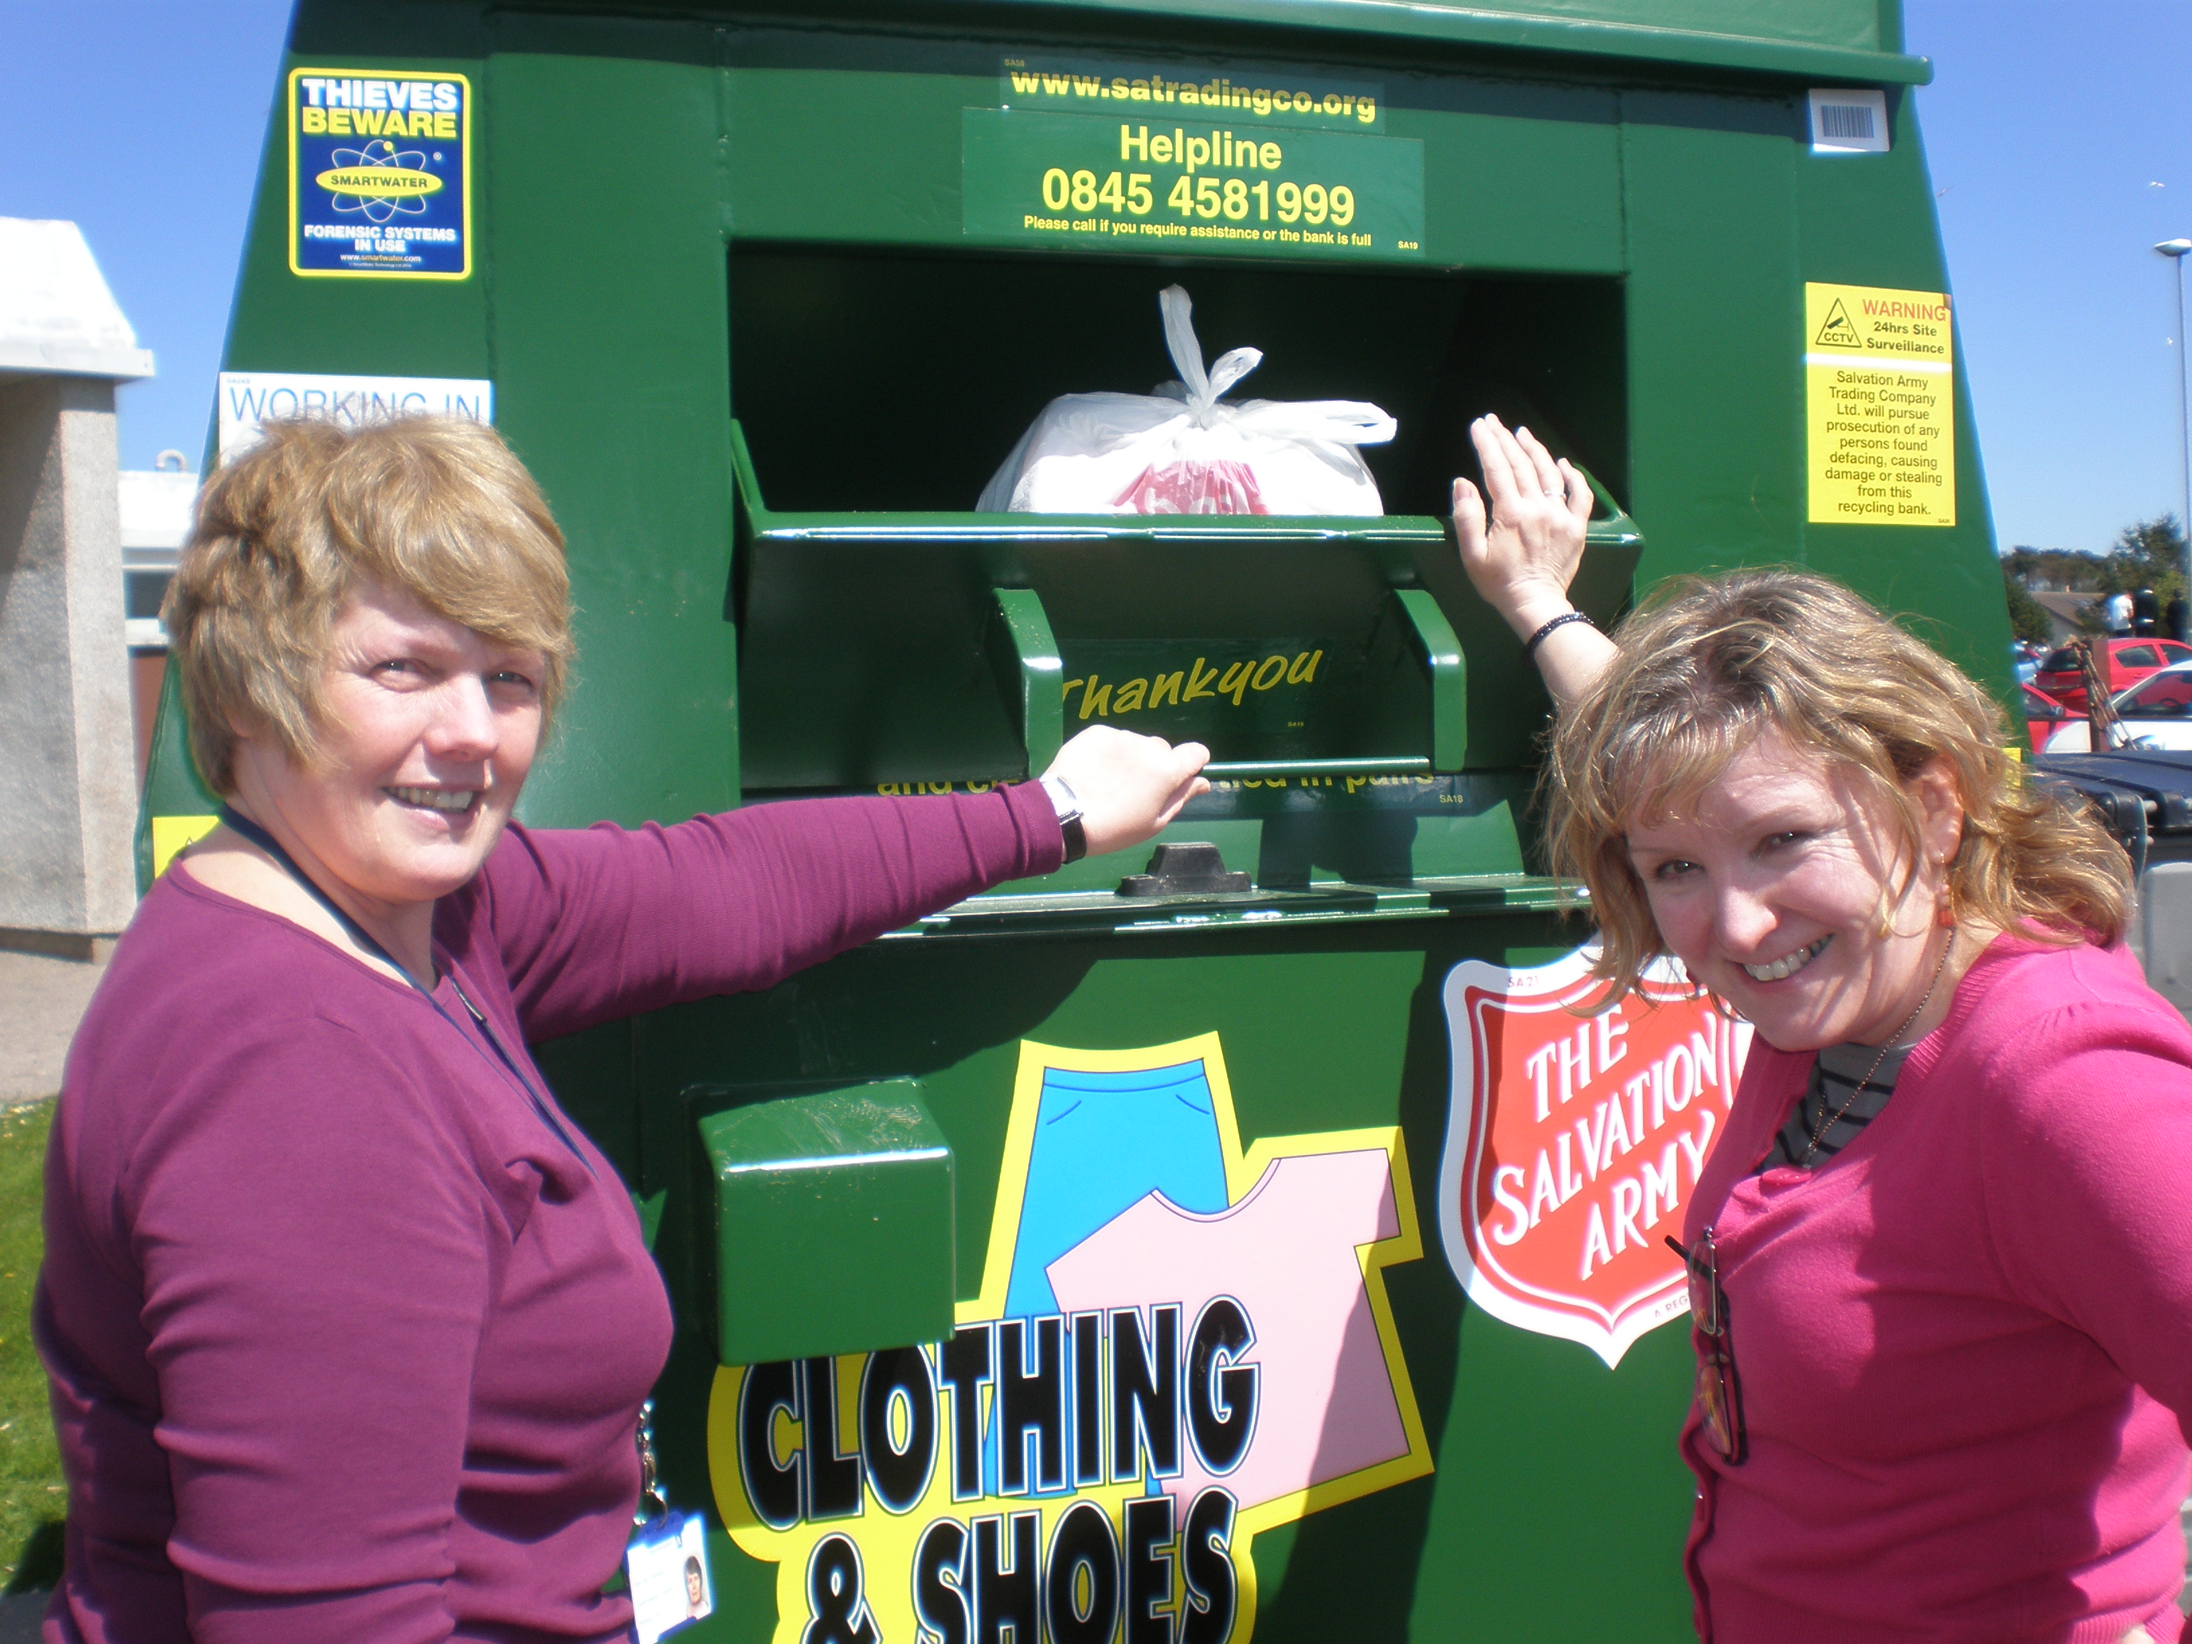

More Eco news next term!
Watch this space!

